**Administrative**

**Today’s session**

Swing API, part 2 of 2

Android application life cycle

**Session Topics**

**Swing API, part 2 of 2**

**Frame layouts**

● **JFrame** is the container for the application.

● **JPanel** is a container for controls.

● A JFrame and JPanel may have one of the following layouts:

✓ BorderLayout (JFrame default)

✓ BoxLayout

✓ CardLayout

✓ FlowLayout (JPanel default)

✓ GridBagLayout

✓ GridLayout

✓ GroupLayout

✓ SpringLayout

● Layouts may be viewed at [docs.oracle.com/javase/tutorial/uiswing/layout/visual.html](http://docs.oracle.com/javase/tutorial/uiswing/layout/visual.html).

● See **GUI frame layout** sample application on Blackboard.

**Controls**

● Package[**javax**](eclipse-javadoc:%E2%98%82=GUI_HorizonCalculator/C:%5C/Program%20Files%5C/Java%5C/jdk1.8.0_91%5C/jre%5C/lib%5C/rt.jar%3Cjavax)**.**[**swing**](eclipse-javadoc:%E2%98%82=GUI_HorizonCalculator/C:%5C/Program%20Files%5C/Java%5C/jdk1.8.0_91%5C/jre%5C/lib%5C/rt.jar%3Cjavax.swing) includes the following controls for building a screen:

✓ **JCheckBox** enables the user to select or unselect an option.

✓ **JRadioButton** enables the user to select from a group of options.

✓ **JColorChooser** enables the user to make color selections.

✓ **JFileChooser** enables the user to make file selections.

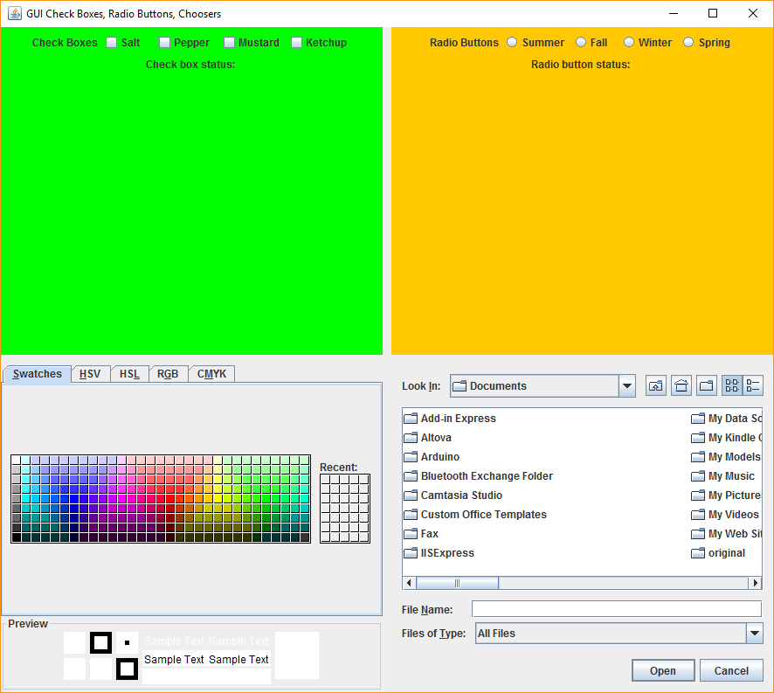

**JCheckBox / check box**

**JRadioButton / radio buttons**

**JFileChooser / file chooser**

**JColorChooser / color chooser**

● See **GUI check boxes, radio buttons, and choosers** sample application on Blackboard.

**Android application life cycle**

● An **activity** is a single, focused thing that the user can do.

● There is typically one activity per screen (defined by a layout).

● An activity continually moves through a series of events.

● We can code the application to respond to any of these events.

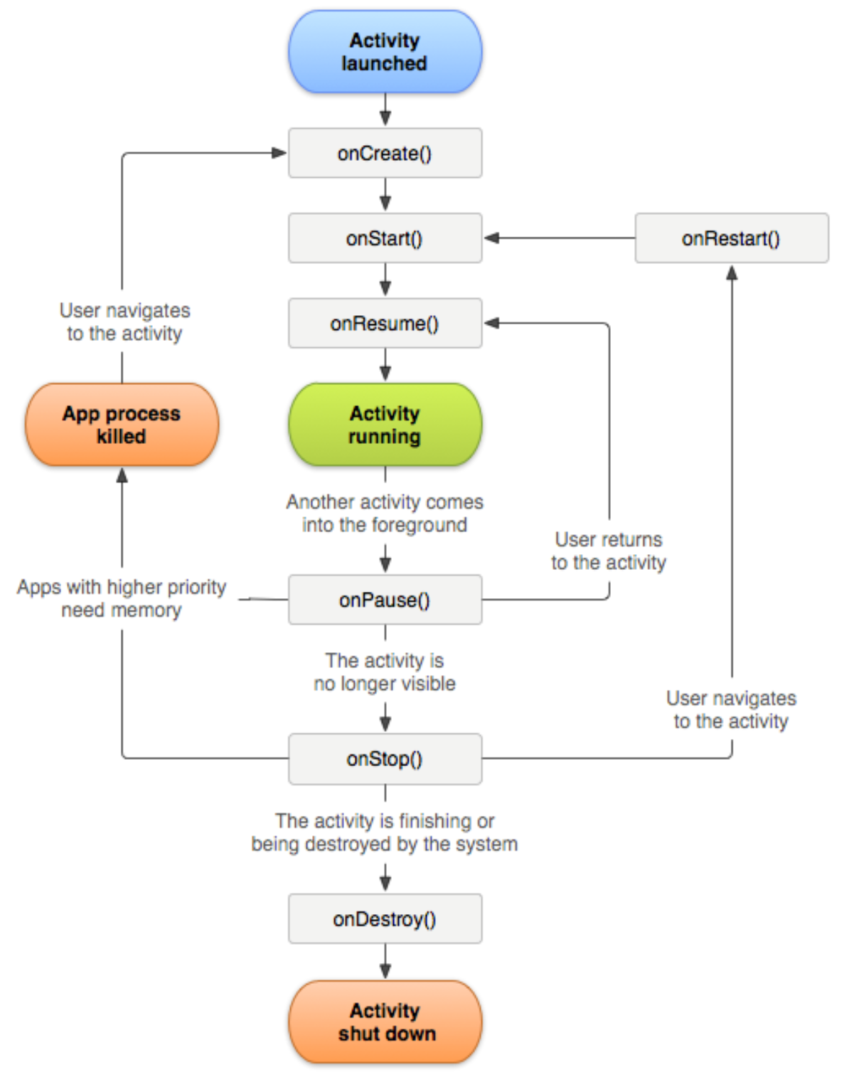

● Things to do in each event:

|  |  |
| --- | --- |
| Event | Things to do |
| onCreate  (required) | Connect to a layout, define referenced controls, define button events. |
| onStart | Apply any changed settings, update control data. Once this event completes, the activity’s screen is visible. |
| onResume | Apply any changed settings, update control data. Once this event completes, the activity’s screen has the focus. |
| onPause | Save any changed settings or data. Once this event completes, the activity’s screen loses the focus and is in the background. It may receive no user input. |
| onStop | Save any changed settings or data. Once this event completes, the activity’s screen loses the focus and is in the background. It may receive no user input. |
| onRestart | Apply any changed settings, update control data. |
| onDestroy | Final save any changed settings or data. Once this event completes, the activity ends. |